Adversarial Search Lab: Minimax and Alpha-Beta Pruning
Hunzala | BS Artificial Intelligence | Superior University Gold Campus

Game Tree Used
The lab uses a game tree of depth 3 with 8 leaves. The root A is a MAX node, B and C are MIN nodes, and D, E, F and G are MAX nodes that hold the leaf values. Leaf values are static evaluations from the point of view of MAX. Children are always visited from left to right in the order listed.
Node | Player | Children (in order)
A | MAX (root) | B, C
B | MIN | D, E
C | MIN | F, G
D | MAX | leaves 3, 5
E | MAX | leaves 6, 9
F | MAX | leaves 1, 2
G | MAX | leaves 0, -1

Lab Task 1: Minimax Traced by Hand
Minimax works from the leaves upwards. A MAX node takes the largest value among its children and a MIN node takes the smallest. The table below shows the order in which I computed the nodes.
Step | Node | Player | Child values | Operation | Value
1 | D | MAX | 3, 5 | max(3, 5) | 5
2 | E | MAX | 6, 9 | max(6, 9) | 9
3 | F | MAX | 1, 2 | max(1, 2) | 2
4 | G | MAX | 0, -1 | max(0, -1) | 0
5 | B | MIN | D = 5, E = 9 | min(5, 9) | 5
6 | C | MIN | F = 2, G = 0 | min(2, 0) | 0
7 | A | MAX | B = 5, C = 0 | max(5, 0) | 5

Result: the Minimax value of the root is 5. MAX should move to B, which is worth 5, and not to C, which is worth only 0, because MIN would answer by choosing the leaf 0 under G.

Lab Task 2: Leaf-Evaluation Counters
I added a counter to the terminal-node case of both functions. Every time a leaf is reached, stats["leaves"] is increased by one and the leaf value is stored in the evaluation order list. Alpha-beta also records its alpha and beta values, its cutoffs and the nodes it enters.

Code
INF = float("inf")

TREE = ("A", [
("B", [("D", [3, 5]), ("E", [6, 9])]),
("C", [("F", [1, 2]), ("G", [0, -1])]),
])

def minimax(node, is_max, stats):
if isinstance(node, int):
stats["leaves"] += 1
stats["order"].append(node)
return node
name, children = node
values = [minimax(child, not is_max, stats) for child in children]
value = max(values) if is_max else min(values)
stats["values"][name] = value
return value

def alphabeta(node, alpha, beta, is_max, stats):
if isinstance(node, int):
stats["leaves"] += 1
stats["order"].append(node)
stats["log"].append(("leaf", node, alpha, beta, stats["leaves"]))
return node
name, children = node
stats["visited"].append(name)
stats["log"].append(("enter", name, alpha, beta, None))
value = -INF if is_max else INF
for child in children:
result = alphabeta(child, alpha, beta, not is_max, stats)
if is_max:
value = max(value, result)
alpha = max(alpha, value)
else:
value = min(value, result)
beta = min(beta, value)
if alpha >= beta:
stats["cuts"].append((name, alpha, beta))
stats["log"].append(("cut", name, alpha, beta, None))
break
stats["log"].append(("return", name, value, None, None))
return value

def new_stats():
return {"leaves": 0, "order": [], "values": {}, "log": [], "cuts": [], "visited": []}

def run_minimax(tree):
stats = new_stats()
value = minimax(tree, True, stats)
return value, stats

def run_alphabeta(tree):
stats = new_stats()
value = alphabeta(tree, -INF, INF, True, stats)
return value, stats

Results on the Original Ordering
Algorithm | Root value | Leaves evaluated | Leaf evaluation order
Minimax | 5 | 8 | 3, 5, 6, 9, 1, 2, 0, -1
Alpha-beta | 5 | 5 | 3, 5, 6, 1, 2

Alpha-Beta Trace
Step | Event | Alpha | Beta | Detail
1 | Enter A | -inf | inf
2 | Enter B | -inf | inf
3 | Enter D | -inf | inf
4 | Leaf 3 | -inf | inf | Leaves evaluated so far: 1
5 | Leaf 5 | 3 | inf | Leaves evaluated so far: 2
6 | Return from D |  |  | Value 5
7 | Enter E | -inf | 5
8 | Leaf 6 | -inf | 5 | Leaves evaluated so far: 3
9 | Cutoff at E | 6 | 5 | alpha >= beta, remaining children skipped
10 | Return from E |  |  | Value 6
11 | Return from B |  |  | Value 5
12 | Enter C | 5 | inf
13 | Enter F | 5 | inf
14 | Leaf 1 | 5 | inf | Leaves evaluated so far: 4
15 | Leaf 2 | 5 | inf | Leaves evaluated so far: 5
16 | Return from F |  |  | Value 2
17 | Cutoff at C | 5 | 2 | alpha >= beta, remaining children skipped
18 | Return from C |  |  | Value 2
19 | Return from A |  |  | Value 5
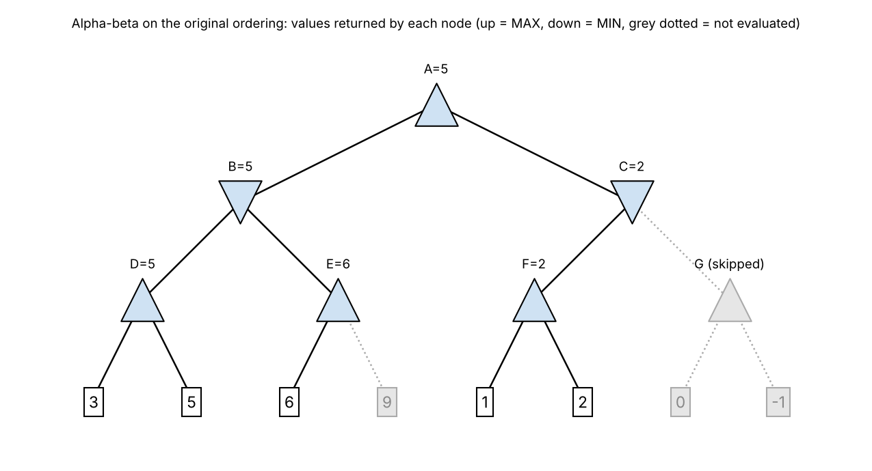
Explanation of the two cutoffs. At E, MIN node B already has the value 5 from D, so beta = 5. After the first leaf 6, alpha at E becomes 6, which is not below beta, so the leaf 9 is skipped: B would never choose E because E gives at least 6. At C, MAX node A already has alpha = 5 from B. After F returns 2, beta at C becomes 2, which is below alpha, so G and its leaves 0 and -1 are skipped: C can give at most 2, so A would never choose it. Alpha-beta evaluated 5 of the 8 leaves and left out 9, 0 and -1.
Verification. Both functions return 5 for the root. The node values and the alpha-beta cutoffs recorded by the code match my hand trace. Note that E returns 6 and C returns 2 in alpha-beta, while their exact Minimax values are 9 and 0. These returned numbers are only bounds, but they do not affect the root value.

Lab Task 3: Reordering Branches
I reordered the children and ran both algorithms again on each version. Alpha-beta pruning depends on how early good bounds are found, so a different order should change the number of leaves evaluated without changing the root value. The five orderings are:
- Original: the tree as supplied.
- Root swapped: only the children of A are reversed, so C is visited before B.
- All reversed: the children of every node are reversed.
- Best-first: MAX nodes try their highest child first and MIN nodes try their lowest child first.
- Worst-first: the opposite of best-first.

Original: A[B[D[3 5] E[6 9]] C[F[1 2] G[0 -1]]]
Root swapped: A[C[F[1 2] G[0 -1]] B[D[3 5] E[6 9]]]
All reversed: A[C[G[-1 0] F[2 1]] B[E[9 6] D[5 3]]]
Best-first: A[B[D[5 3] E[9 6]] C[G[0 -1] F[2 1]]]
Worst-first: A[C[F[1 2] G[-1 0]] B[E[6 9] D[3 5]]]

Ordering | Root value | Minimax leaves | Alpha-beta leaves | Pruned | Leaves evaluated (alpha-beta order) | Cutoffs: node(alpha, beta)
Original | 5 (both) | 8 | 5 | 3 | 3 5 6 1 2 | E(6,5), C(5,2)
Root swapped | 5 (both) | 8 | 7 | 1 | 1 2 0 -1 3 5 6 | E(6,5)
All reversed | 5 (both) | 8 | 7 | 1 | -1 0 2 9 6 5 3 | F(2,0)
Best-first | 5 (both) | 8 | 5 | 3 | 5 3 9 0 -1 | E(9,5), C(5,0)
Worst-first | 5 (both) | 8 | 8 | 0 | 1 2 -1 0 6 9 3 5 | none
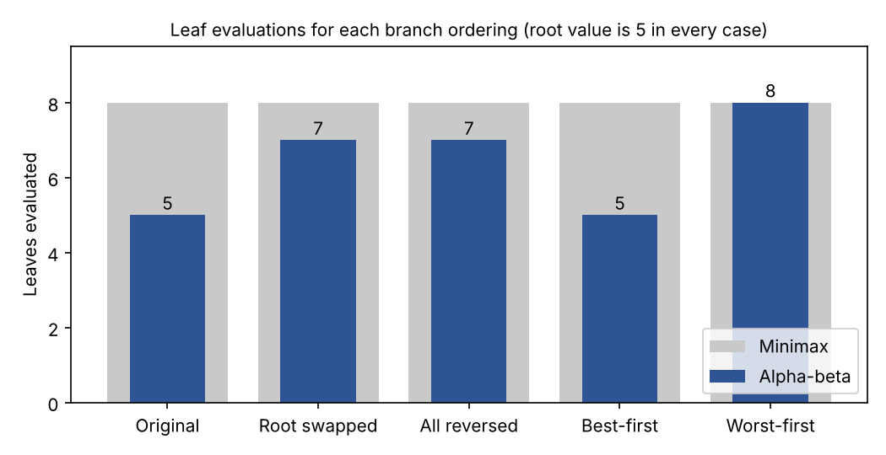
Observation. The root value is 5 for every ordering and for both algorithms, but the number of leaves evaluated by alpha-beta is 5, 7, 7, 5 and 8. Minimax always evaluates all 8 leaves. With worst-first ordering no cutoff happens, so alpha-beta does as much work as Minimax. With root swapped, A first meets C and only gets alpha = 0, so the cutoff at C is lost and 7 leaves are needed.
Why the original ordering is already good. For a uniform tree with branching factor b and depth d, the smallest possible number of leaves that alpha-beta must evaluate is b^ceil(d/2) + b^floor(d/2) - 1 (Knuth and Moore, 1975). Here b = 2 and d = 3, which gives 4 + 2 - 1 = 5. The original ordering and the best-first ordering both reach this minimum, so no ordering can do better than 5 leaves on this tree.

Program Output
Minimax root value: 5 | leaves evaluated: 8 | leaf order: [3, 5, 6, 9, 1, 2, 0, -1]
Alpha-beta root value: 5 | leaves evaluated: 5 | leaf order: [3, 5, 6, 1, 2]
Node values (minimax): {'D': 5, 'E': 9, 'B': 5, 'F': 2, 'G': 0, 'C': 0, 'A': 5}
Cutoffs (node, alpha, beta): [('E', 6, 5), ('C', 5, 2)]
Root values agree: True
Hand trace values match: True
Hand trace alpha-beta leaves match: True

Original | A[B[D[3 5] E[6 9]] C[F[1 2] G[0 -1]]] | values: 5 5 | minimax leaves: 8 | alpha-beta leaves: 5 | evaluated: [3, 5, 6, 1, 2] | cuts: [('E', 6, 5), ('C', 5, 2)]
Root swapped | A[C[F[1 2] G[0 -1]] B[D[3 5] E[6 9]]] | values: 5 5 | minimax leaves: 8 | alpha-beta leaves: 7 | evaluated: [1, 2, 0, -1, 3, 5, 6] | cuts: [('E', 6, 5)]
All reversed | A[C[G[-1 0] F[2 1]] B[E[9 6] D[5 3]]] | values: 5 5 | minimax leaves: 8 | alpha-beta leaves: 7 | evaluated: [-1, 0, 2, 9, 6, 5, 3] | cuts: [('F', 2, 0)]
Best-first | A[B[D[5 3] E[9 6]] C[G[0 -1] F[2 1]]] | values: 5 5 | minimax leaves: 8 | alpha-beta leaves: 5 | evaluated: [5, 3, 9, 0, -1] | cuts: [('E', 9, 5), ('C', 5, 0)]
Worst-first | A[C[F[1 2] G[-1 0]] B[E[6 9] D[3 5]]] | values: 5 5 | minimax leaves: 8 | alpha-beta leaves: 8 | evaluated: [1, 2, -1, 0, 6, 9, 3, 5] | cuts: []
Same root value for every ordering: True

Edge case: Single leaf as root | minimax 7 1 | alpha-beta 7 1
Edge case: All 8 leaves equal to 4 | minimax 4 8 | alpha-beta 4 5
Random trees (depth 4, branching 3, 81 leaves), trials: 1000 | root values agree: 1000 | avg alpha-beta leaves random/best/worst: 42.6 17.0 77.5

Edge Cases, Comparison and Limitations

Edge Cases
Case | Minimax value | Alpha-beta value | Minimax leaves | Alpha-beta leaves
Single leaf as root | 7 | 7 | 1 | 1
All 8 leaves equal to 4 | 4 | 4 | 8 | 5

When the root is a single leaf both algorithms return it after one evaluation. When all leaves are equal, alpha-beta still prunes (5 leaves instead of 8), because a cutoff happens when alpha is greater than or equal to beta, so equal values also trigger it. The returned value is still correct.

Random Tree Check
To test more than one tree I generated 1000 random trees with depth 4, branching factor 3 and 81 leaves, with random leaf values from -9 to 9. The root values of Minimax and alpha-beta agreed in 1000 of 1000 trees, also after reordering with the best-first and worst-first orderings. The average number of leaves evaluated by alpha-beta was 42.6 for the random order, 17 for best-first and 77.5 for worst-first, out of 81 for Minimax. The best-first average matches the formula above, 3^2 + 3^2 - 1 = 17.

Limitations and Failure Analysis
- The best-first and worst-first orderings use the Minimax values of the nodes, so they need the answer that the search is trying to find. A real program has to guess a good order with heuristics, for example by trying captures first, so its savings lie between the best and the worst case.
- In the worst ordering alpha-beta saves nothing (8 leaves, 8 leaves). Pruning never gives a wrong root value, but it gives no guarantee of speed.
- Alpha-beta gives exact values only for the nodes on the best line. The values 6 at E and 2 at C are bounds, so the pruned search cannot be used to rank all moves exactly.
- Both algorithms assume a two-player, zero-sum game with perfect information and fixed leaf evaluations. The result is only as good as those evaluations, and the tree here is a small lab example.

Connection to the Learning Outcome
This lab connects to the learning outcome of using adversarial search to choose moves in two-player games and of analysing the cost of that search. Minimax gives the optimal value when the opponent also plays optimally, and alpha-beta gives the same value while avoiding branches that cannot change the decision. The experiments show that the saving comes from the order in which moves are tried, and that the gain ranges from none in the worst case to roughly the square root of the Minimax work in the best case.

Reflection and Responsible Practice
Reflection. Before this lab I thought alpha-beta was just a faster Minimax. Tracing it by hand showed me that it is the same decision with a different amount of work, and that the order of the moves matters. The most useful surprise was that the original ordering was already the best possible, and that simply swapping the root children made it worse. Counting leaves made the effect of ordering visible and measurable.
Responsible practice. I checked that the code agrees with my hand trace before trusting its output, and I tested edge cases and many random trees instead of relying on one example. I report the cases where pruning does not help, and I state that the best-first ordering is an oracle that real programs do not have. The lab tree is small, so I do not claim that the exact counts apply to real games. Search programs that choose moves in games or other decisions should be tested in this way, because a fast result is not useful unless it is also correct and its limits are stated.

References
Knuth, D. E., & Moore, R. W. (1975). An analysis of alpha-beta pruning. Artificial Intelligence, 6(4), 293-326.
Russell, S., & Norvig, P. (2021). Artificial Intelligence: A Modern Approach (4th ed.). Pearson.

